**21. Draw aggregation associations of all your classes**

DATABASE

Users Table

User Panel

Admin Panel

DATABASE

Issues Table

SUPPORT

NEWS, CONTACT

SIGN UP PAGE

HOMEPAGE

PAYMENT

LOGIN PANEL

P

DATABASE

Users Table

File System

Compress w/ LZX

App

Website Panel

App Login Screen

**22. Draw activity model of your application**

**yes**

ADMIN PANEL

IF ACCESS LEVEL=1

If info true

Enter Login İnformation

Have an account ?

**No**

LOGIN PANEL

P

DATABASE

Users Table

If info false

Sign Up

Payment and settings

P

Error

DATABASE

Issues Table

Enter info

Support

Salary Control

User Control

Admin Panel

Read Comments

C Panel

App Login Screen

DATABASE

Users Table

App

Website Panel

Compress w/ LZX

File System

**23. Draw your application processes**

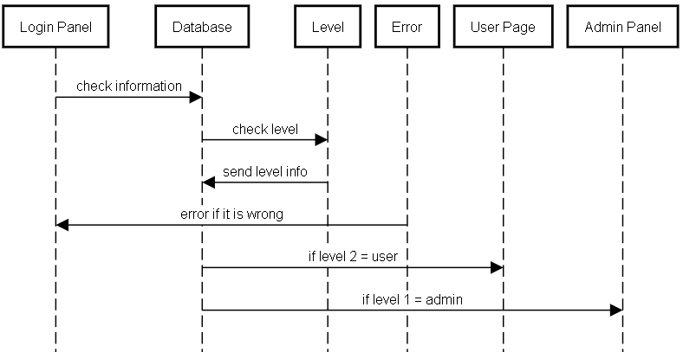

**24. Draw state diagram of your application**

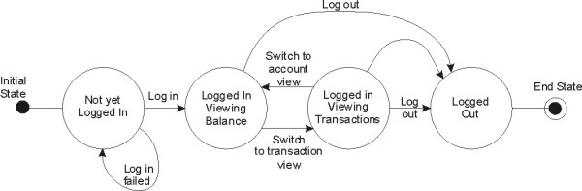

**25. Prepare structured forms of your application’s states**

|  |  |
| --- | --- |
| **Stimulus** | **Description** |
| **Home** | **Home page** |
| **Login** | **Login page** |
| **Signup** | **Signup page** |
| **User Panel** | **User account settings and payment** |
| **Payment** | **Payment page for buying our product** |
| **Admin Panel** | **Admin Panel to control users and payments** |
| **News** | **Latest updates** |
| **Support** | **It has a form user enter problem. It is in the database and can read by admin** |
| **Contact** | **Contact informations** |
| **App Login Panel** | **Login informations** |
| **App Panel** | **A web browser to reach website** |
| **App** | **With full of functions to compress files and it can be automatically by hours.** |

**26. Draw the software architecture of your Project**

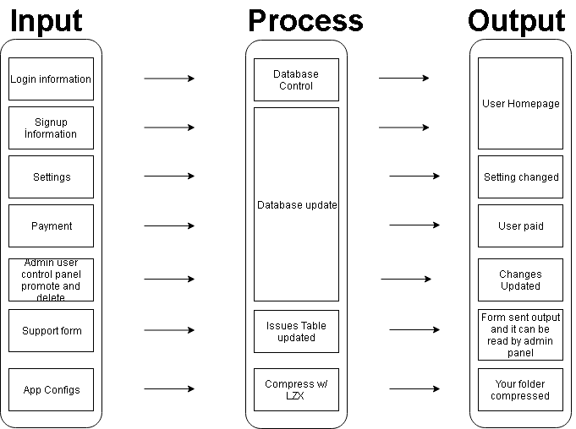

**27. Draw context diagram of your Project**

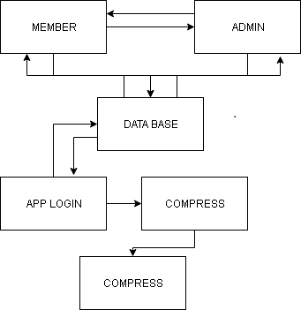

**28. Draw high level architecture of your Project**

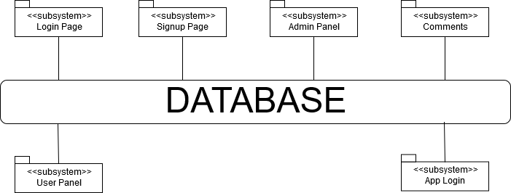

**29. Draw all object classes of your project**

